15 June 2020

|  |  |  |  |
| --- | --- | --- | --- |
| Date: | 15 June 2020 | Name: | Srinidhi J C |
| Course: | Digital Marketing | USN: | 4al16ec078 |
| Topic: |  | Semester & Section: | 8th & b |
| Github Repository: | SrinidhiJC078 |  |  |

|  |
| --- |
| FORENOON SESSION DETAILS |
| Image of session   |

Report:

Today’s era of Internet has opened a gate of vast variety of opportunities for businesses. Using social networks, one cannot only share a private picture of one’s birthday but also earn customers for one’s business and reach them conveniently. The speed and ease with which the digital media transmits information and help boost a business is amazing.

Let us first throw some light on the scope of digital marketing.

## **What is Digital Marketing?**

Digital Marketing is the term used for the targeted, measurable, and interactive marketing of products or services using digital technologies to reach the viewers, turn them into customers, and retain them.

So, how is digital marketing different from traditional marketing?

The traditional manner of marketing involved businesses to advertise their products or services on print media, radio and television commercials, business cards, bill boards, and in many other similar ways where Internet or social media websites were not employed for advertising. Traditional marketing policies had limited customer reachability and scope of driving customers’ buying behavior.

Digital marketing achieves targets of marketing a business through different online channels. Let us see how.

The following table lists a few points that differentiate digital marketing from traditional marketing −

|  |  |
| --- | --- |
| **Traditional Marketing** | **Digital Marketing** |
| Communication is unidirectional. Means, a business communicates about its products or services with a group of people. | Communication is bidirectional. The customer also can ask queries or make suggestions about the business products and services. |
| Medium of communication is generally phone calls, letters, and Emails. | Medium of communication is mostly through social media websites, chat, and Email. |
| Campaigning takes more time for designing, preparing, and launching. | There is always a fast way to develop an online campaign and carry out changes along its development. With digital tools, campaigning is easier. |
| It is carried out for a specific audience throughout from generating campaign ideas up to selling a product or a service. | The content is available for general public. It is then made to reach the specific audience by employing search engine techniques. |
| It is conventional way of marketing; best for reaching local audience. | It is best for reaching global audience. |
| It is difficult to measure the effectiveness of a campaign. | It is easier to measure the effectiveness of a campaign through analytics. |

## **Social Media Marketing**

Social Media Marketing is the manner of generating website traffic or attracting viewers and customers through social networking websites such as Facebook, Pinterest, LinkedIn, Twitter, and so on. Social media marketing is a subset of digital marketing.



All social networking websites support sharing of content, but all are not necessarily employed for digital marketing. While Facebook emphasizes on personal sharing, Twitter emphasizes on tweeting short messages about ones’ opinions or reactions, and LinkedIn goes for professional networking, Pinterest motivates to market one’s ideas and online businesses.

## **Principle of Social Media Marketing**

Social media grew up as the most popular outcome of the Internet as people around the world like to communicate and share their special moments, problems, ideas, and suggestions with others. They also like to learn about a place worth visiting, a new craft projects, recipes, or a new language. Social media websites enable you to share content of your choice with right audience at your convenience.

This popularity of social media has inspired the business minds around the world with the idea of small online businesses. One can open a store in Amazon, eBay, or any other custom platforms such as Shopify or Etsy. But the main challenge is finding the customers. There are ways like search results in Google, Bing or in any other search engine. But for a new business with established competitors, it takes a long time to get a high rank in the search results.

Social networking websites are a great solution to this challenge. The basic technique here is to share engaging posts and the right content created for the desired audience. Then the audience helps by sharing the content further, which in turn reaches further. Hence there is another option of advertising the product, services, or ideas on the social networking websites where there is less degree of competition.

**Facebook Marketing**

Facebook provides insight into its users’ interests, likes, dislikes, personal life and buying behavior. In addition, it also provides a large database of information that can be tapped into by your business or organization to generate high quality leads, sales enquiries and traffic to your website.

# **Audience**

This tutorial is for those who wish to make or strengthen their stand in the market through Facebook as one of the social media platforms. The audience of this tutorial is expected to have a basic understanding of digital marketing and good communication skills.

# **Prerequisites**

We assume that you have the creative skills required to help you stand out in the field of digital marketing.

Utilizing Facebook for your digital marketing strategy is without doubt one of the best ways to connect and grow a social following online. Being one of the largest social media platforms, it provides insight into its users’ interests, likes, dislikes, personal life and buying behavior. This large database of information can be tapped into by your business or organization to generate high quality leads, sales enquiries and traffic to your website.

## **Types of Facebook Pages**

Facebook pages assist businesses, brands and organizations in sharing information and reaching out to people. Users like the pages that they are interested in. With this, they can stay in touch and get updates about different activities. There are a number of different pages you can create depending on what sort of organization you are starting.

Following is a list of the types of Facebook pages that you can create −

* Local business or place
* Company, organization or institution
* Brand or product
* Artist, band or public figure
* Entertainment
* Cause or community

## **How can posts be effective to grow your business**

Facebook is a fantastic way to reach out to your audience on different levels. By posting information, photos, videos and stories, the content you share can −

* Personalize your brand
* Drive users to your blog
* Generate more traffic directly to your website
* Educate and create awareness about your industry
* Promote the culture of your organization

Facebook marketing is completely scalable as you create campaigns that are realistic and relevant to your brand. All of this is completely measurable by utilizing Facebook analytics, giving you the ability to test, evaluate and adjust the strategy that you are currently implementing.

You can change the page whenever and as many times as you would like after the setup. The only thing to keep note of is that if you change from a business or local place you will lose your reviews, maps and check-ins.

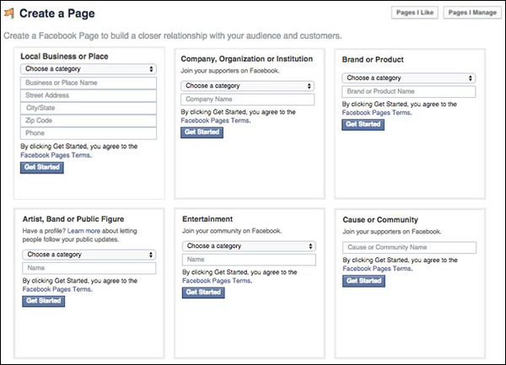

The image above is what the information fields look like when you click on one of the categories in ***‘create a page’***.

## **Adding page details**

The Facebook wizard will guide you through the process quite easily when you are creating your page. If you have decided that your page is a Local Business or Place, you can add tags that help improve the ranking of your page (which will increase visibility when people are searching interests related to your business).

You can also add a detailed description, website link and a custom Facebook web URL. You will also be required to confirm that you are the authorized representative to create a Facebook page for the business. Once you have finished this step, you will then be asked to add a profile picture, add the page to your favorites and have the option to claim any duplicate pages relating to your business.

The last step to getting your business or place page set up is to choose your preferred page audience. This will let Facebook know what demographics should see your page. The setting up of Facebook pages for other categories are fairly similar.

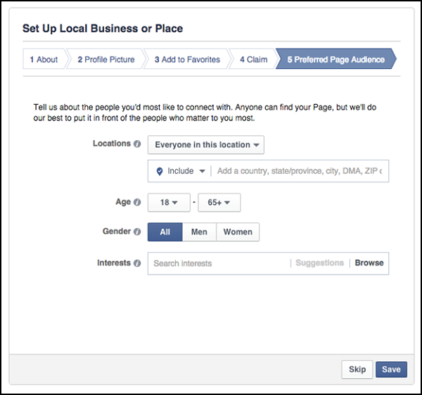

Once you have completed the Setup Wizard, you will be directed to your new page. It will look empty except for the information you put in during the setup

After completing the initial setup, you will be redirected to your new Facebook page. Apart from the information you provided in the setup process, it will look rather empty. In this chapter, we will show you how to navigate through different areas of the page so that you are comfortable with modifying and utilizing the functionalities

In the ‘About’ tab, you can ensure that all your business details have been entered correctly. The areas you can update/modify include −

* Address
* Contact details
* Website URL
* Operating Hours
* Price Range

You can also include a brief description about your business.

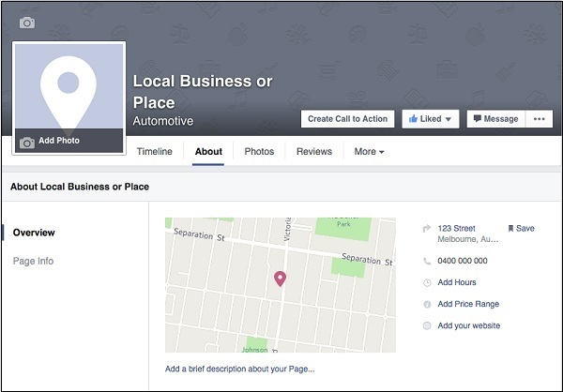

## **Adding a display picture and a cover photo**

To add a display picture and a cover photo, you will need to click on the camera icon located within the designated areas (see picture below). In general, the display picture should represent your business with either a logo or icon that people will familiarize with your brand. The cover photo is a great way to show off what makes your brand shine by giving your users a graphical image that promotes your service. Depending on the culture and values of your organization this can be professional, creative, informative or a mix, there are no set rules, it will depend on how you want to market yourself.

**Display picture size** − 180px x 180px

**Cover photo size** − 851px x 315px

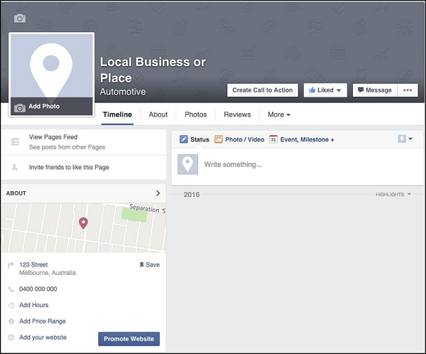

## **Create a ‘call-to-action’ button**

Creating a call-to-action button on your page enables your audience to straight away be taken to a desired location. This is a great way to start generating leads, get traffic, bookings, subscriptions and much more. You will be able to choose what type of button you would like to have displayed and where it will take someone if they click on it. You can create call-to-action buttons for desktop, iPhone and Android.

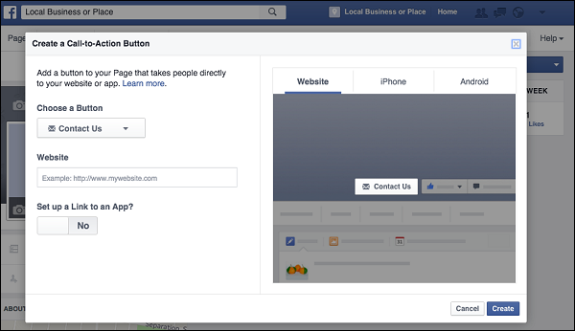

The image above is to create call-to-action button.

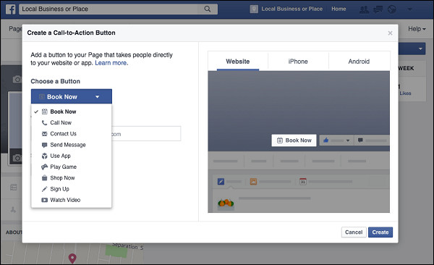

The image above shows the different types of buttons you can have displayed on your page.

## **Setting**

The settings tab gives you the access to monitor and perform adjustments on your page. In the general page, you can choose whether your page is public or private. In the initial phase of setting up your page, you may wish to change the status of the page to private until you are ready for people to start finding/seeing what you are up too. Here you can also set who can post on your wall, you can choose to either just let the admin post or let your fans and people who find your page, post and comment on your wall. You can also set who can tag photos, message you privately, restrict age to see the page and which countries it will be available for. You can also merge duplicate pages you have or delete the page entirely.

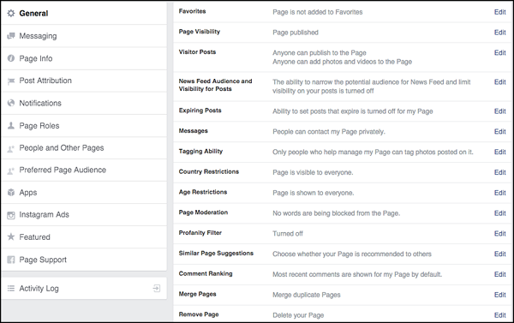

Other notable areas in the settings are −

**Page roles** − Choose to add new people in to your page as either an admin, editor, moderator, adviser or analyst.

**Messaging** − Show your average response time in getting back to private messages. You can also let people know that you will be either just as or less responsive outside of business hours.

**Preferred page audience** − Change who finds your page by optimizing the age criteria, location, gender and users’ interests.

|  |  |  |  |  |
| --- | --- | --- | --- | --- |
| Date: | 15s June 2020 | Name: | Srinidhi J C | |
| Course: | IOT in Python with Rosberry Pi | USN: | 4al16ec078 | |
| Topic: | Full Duplex IoT Server and AWS Deployment | Semester & Section: | 8th & b | |
| AFTERNOON SESSION DETAILS | | | |
| Image of session | | | |

Report:

# **AWS IoT Core features**

AWS IoT Core is a platform that enables you to connect devices to AWS Services and other devices, secure data and interactions, process and act upon device data, enables applications to interact with devices even when they are offline and that allows you to produce low-cost Alexa built-in devices.

## **Key features**

### **AWS IoT Device SDK**

The AWS IoT Device SDK helps you easily and quickly connect your hardware device or your mobile application to AWS IoT Core. The AWS IoT Device SDK enables your devices to connect, authenticate, and exchange messages with AWS IoT Core using the MQTT, HTTP, or WebSockets protocols. The AWS IoT Device SDK supports C, JavaScript, and Arduino, and includes the client libraries, the developer guide, and the porting guide for manufacturers. You can also use an open source alternative or write your own SDK.

### **Device Gateway**

The Device Gateway serves as the entry point for IoT devices connecting to AWS. The Device Gateway manages all active device connections and implements semantics for multiple protocols to ensure that devices are able to securely and efficiently communicate with AWS IoT Core. Currently the Device Gateway supports the MQTT, WebSockets, and HTTP 1.1 protocols. For devices that connect using MQTT or WebSockets the Device Gateway will maintain long lived, bidirectional connections, enabling these devices to send and receive messages at any time with low latency. The Device Gateway is fully managed and scales automatically to support over a billion devices without requiring you to manage any infrastructure. For customers migrating to AWS IoT, the Device Gateway offers capabilities to transition infrastructures with minimal impact to existing architectures and IoT devices.

### **Message Broker**

The Message Broker is a high throughput pub/sub message broker that securely transmits messages to and from all of your IoT devices and applications with low latency. The flexible nature of the Message Broker’s topic structure allows you to send messages to, or receive messages from, as many devices as you would like. It supports messaging patterns ranging from one-to-one command and control messaging, to one-to-one million (or more!) broadcast notification systems and everything in between. In addition, you can set up fine grained access controls that enable you to manage the permissions of individual connections at the topic level, ensuring that your devices and applications will only send and receive the data that you want them to. The Message Broker is a fully managed service, so no matter how you choose to use it, it will scale automatically with your message volume without requiring you to run any infrastructure.

### **Authentication and Authorization**

AWS IoT Core provides mutual authentication and encryption at all points of connection, so that data is never exchanged between devices and AWS IoT Core without a proven identity. AWS IoT Core supports the AWS method of authentication (called ‘SigV4’), X.509 certificate based authentication, and customer created token based authentication (through custom authorizers.) Connections using HTTP can use any of these methods, while connections using MQTT use certificate based authentication, and connections using WebSockets can use SigV4 or custom authorizers. With AWS IoT Core you can use AWS IoT Core generated certificates, as well as those signed by your preferred Certificate Authority (CA). You can map your choice of policies to each certificate, so that you can authorize devices or applications to have access, or change your mind and revoke access altogether without ever touching the device.

You can create, deploy and manage certificates and policies for the devices from the console or using the API. Those device certificates can be provisioned, activated and associated with the relevant IoT policies that are configured using AWS IoT Core. This allows you to instantly revoke access for an individual device if you choose to do so. AWS IoT Core also supports connections from users’ mobile apps using Amazon Cognito, which takes care of all the steps necessary to create a unique identifier for your app’s users and retrieve temporary, limited-privilege AWS credentials. AWS IoT Core can also provide temporary AWS credentials after a device has authenticated with an X.509 certificate, so that the device can more easily access other AWS services such as DynamoDB or S3.

Fleet provisioning for AWS IoT Core makes it easy to onboard any number of manufactured devices to the cloud at scale. It provides an end-to-end managed device onboarding experience that sets up devices with unique digital identities and performs the device-side and cloud-side configuration needed for each device to connect and operate with AWS IoT automatically upon its first connection to AWS IoT Core. Fleet provisioning is offered at no additional charge to customers.

### **Registry**

The Registry establishes an identity for devices and tracks metadata such as the devices’ attributes and capabilities. The Registry assigns a unique identity to each device that is consistently formatted regardless of the type of device or how it connects. It also supports metadata that describes the capabilities of a device, for example whether a sensor reports temperature, and if the data are Fahrenheit or Celsius.

The Registry lets you store metadata about your devices at no additional charge, and metadata in the Registry does not expire as long as you access or update your registry entry at least once every 7 years.

### **Device Shadow**

With AWS IoT Core, you can create a persistent, virtual version, or Device Shadow, of each device that includes the device’s latest state so that applications or other devices can read messages and interact with the device. The Device Shadow persists the last reported state and desired future state of each device even when the device is offline. You can retrieve the last reported state of a device or set a desired future state through the API or using the rules engine.

The Device Shadow makes it easier to build applications that interact with your devices by providing always available REST APIs. In addition, applications can set the desired future state of a device without accounting for the devices current state. AWS IoT Core will compare the difference between the desired and last reported state, and command the device to make up the difference.

The AWS IoT Device SDK makes it easy for your device to synchronize its state with its Device Shadow, and to respond to desired future states set via the Device Shadow.

The Device Shadow lets you store the state of your devices for up to a year for free. The Device Shadow persist forever if you update them at least once per year, otherwise they expire.

### **Rules Engine**

The Rules Engine makes it possible to build IoT applications that gather, process, analyze and act on data generated by connected devices at global scale without having to manage any infrastructure. The Rules Engine evaluates inbound messages published into AWS IoT Core and transforms and delivers them to another device or a cloud service, based on business rules you define. A rule can apply to data from one or many devices, and it can take one or many actions in parallel.

The Rules Engine can also route messages to AWS endpoints including AWS IoT Analytics, AWS IoT Events, AWS Lambda, Amazon Kinesis, Amazon S3, Amazon DynamoDB, Amazon CloudWatch, Amazon Simple Notification Service (SNS), Amazon Simple Queue Service (SQS), Amazon Elasticsearch Service, and AWS Step Functions. External endpoints can be reached using AWS Lambda, Amazon Kinesis, Amazon SNS, and Rules Engine’s native HTTP action.

You can author rules within the management console or write rules using a SQL-like syntax. Rules can be authored to behave differently depending upon the content of the message. For example, if a temperature reading exceeds a certain threshold it could trigger a rule to transmit data to AWS Lambda. Rules can also be authored to take into account other data in the cloud, such as data from other devices. For example you could say take an action if this temperature is more than 15% higher than the average of 5 other devices.

The Rules Engine provides dozens of available functions that can be used to transform your data, and it’s possible to create infinitely more via AWS Lambda. For example, if you’re dealing with a wide range of values you could take the average of incoming numbers. Rules can also trigger the execution of your Java, Node.js or Python code in AWS Lambda, giving you maximum flexibility and power to process device data.